**CLOUD AWS**

**HANDS ON**

**S3 STATIC WEB HOSTING**

**NAME: SHAMBHAVI SHUKLA**

**EMPLOYEE ID: 2320529**

**COHORT CODE: CSDAIA24DB002**

**SIMPLE STORAGE SERVICE (S3):**

Amazon Simple Storage Service (Amazon S3) is an object storage service that provides exceptional scalability, robust data availability, stringent security measures, and high performance. It is a type of platform as a service (PAAS). When using Amazon S3, you interact with two primary resources: buckets and objects.

**Buckets:**

A bucket serves as a container for your objects. It’s where you organize and manage your data.

Think of it as a virtual storage bin where you can store files, images, videos, and more.

Each bucket has a globally unique name within the Amazon S3 namespace.

**Objects:**

An object represents a file along with any associated metadata.

Metadata includes details like file type, creation date, and permissions.

Objects can be anything from documents to multimedia files.

Naming rules for S3 bucket:

1. Bucket names must be between 3 (min) and 63 (max) characters long.
2. Bucket names can consist only of lowercase letters, numbers, dots (.), and hyphens (-).
3. Bucket names must begin and end with a letter or number.
4. Bucket names must not contain two adjacent periods.
5. Bucket names must not be formatted as an IP address (for example, 192.168.5.4).

**Key Features:**

1. Scalability: S3 can handle massive amounts of data.
2. Data Availability: High durability and availability.
3. Security: Encryption, access control, and compliance features.
4. Performance: Low-latency access.
5. Management: Organize and configure data access.

**Steps for static website hosting using S3 bucket**

1. Creation of a S3 bucket

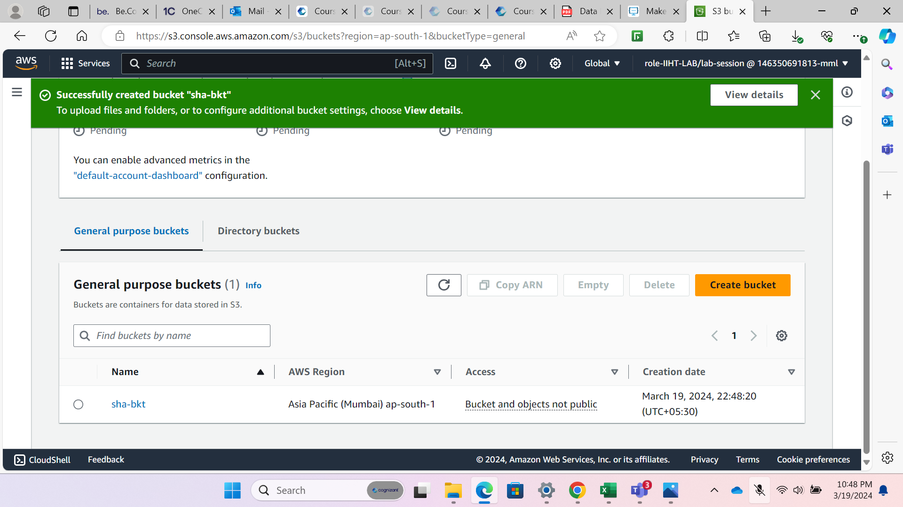

1. Set permissions by applying bucket policy and allowing public access to the bucket.

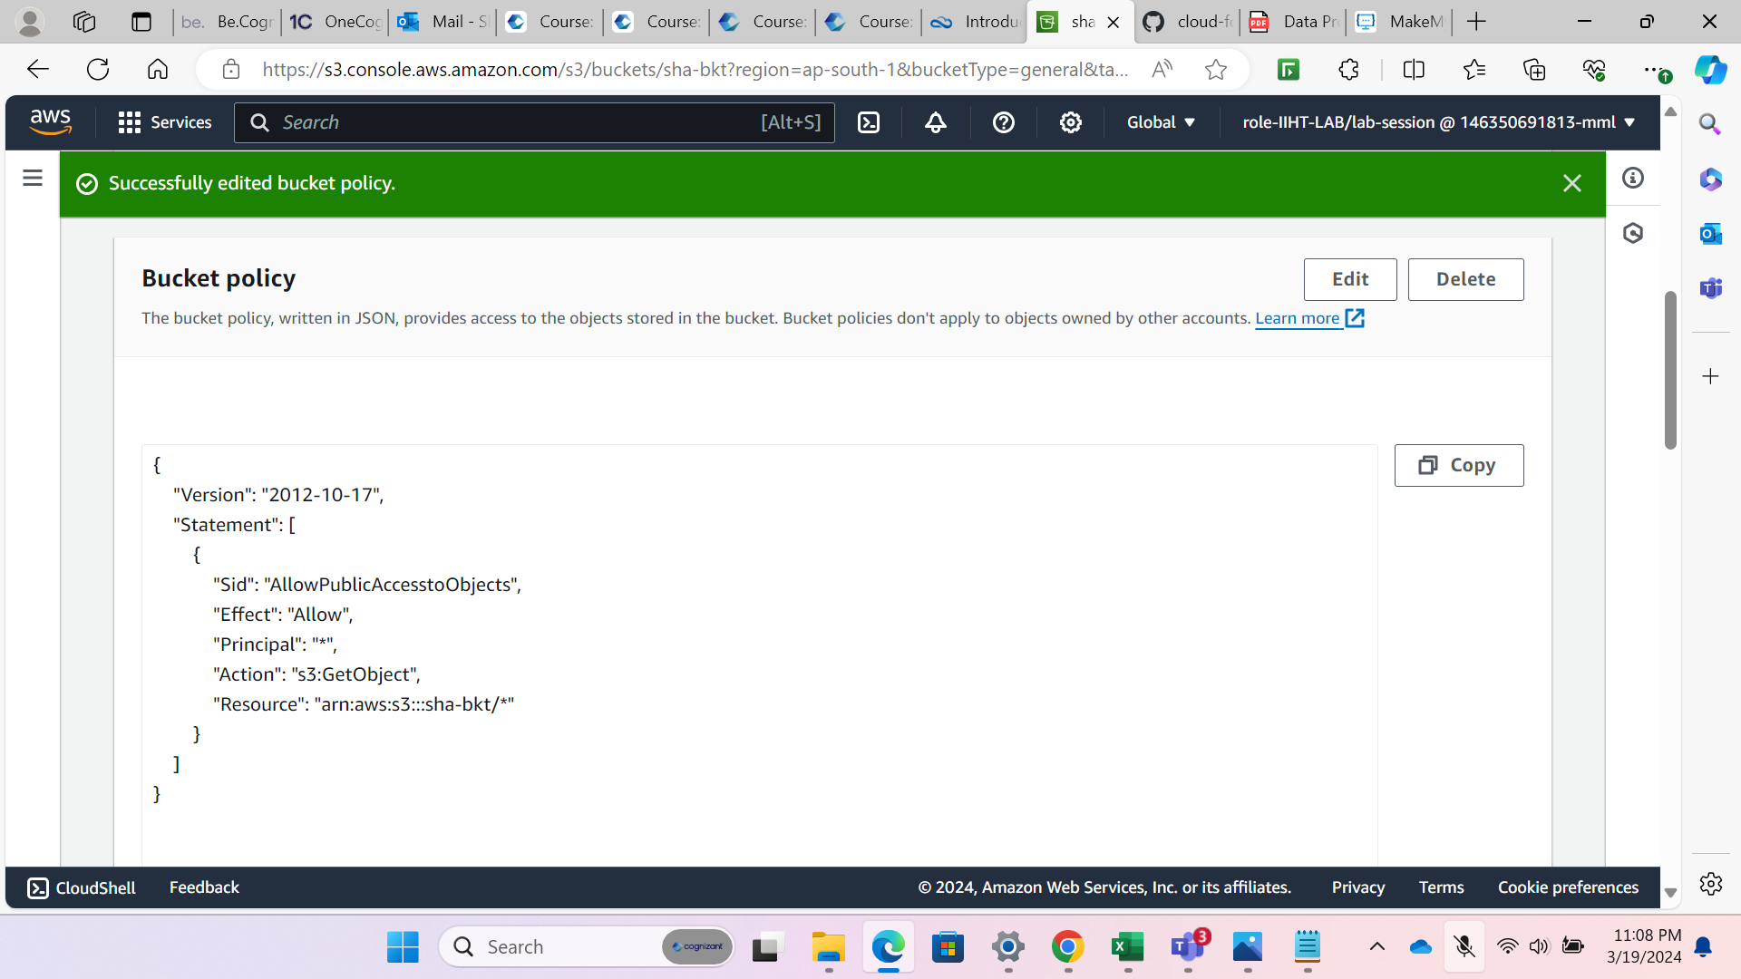

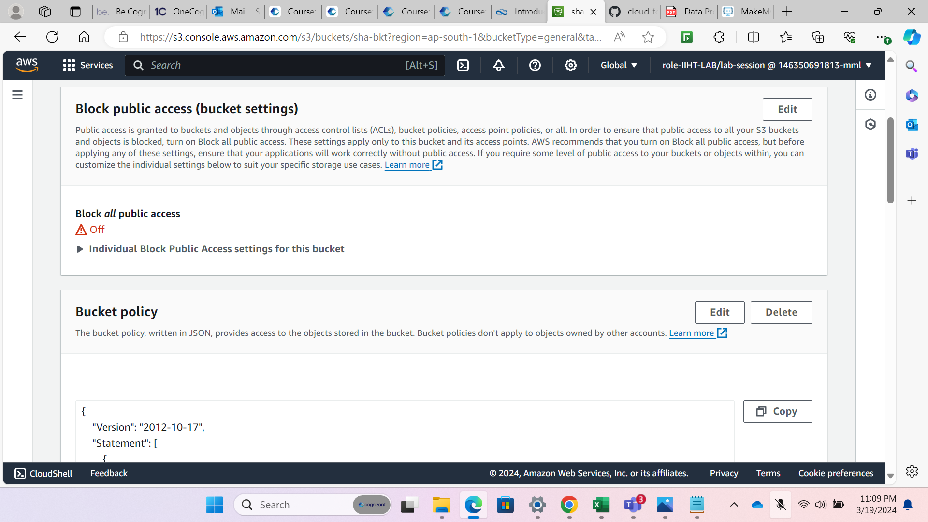

1. Upload the index.html and error.html file in the bucket.

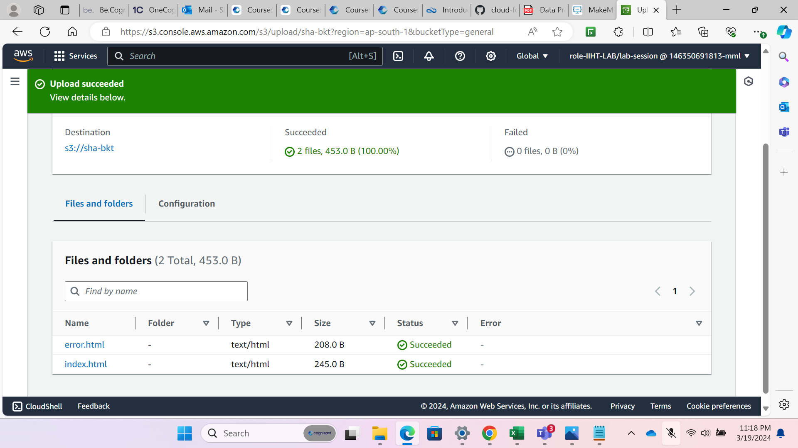

1. Enable static website hosting S3 buckets->properties->Static website hosting->Enable to generate the bucket website endpoint. Copy the url

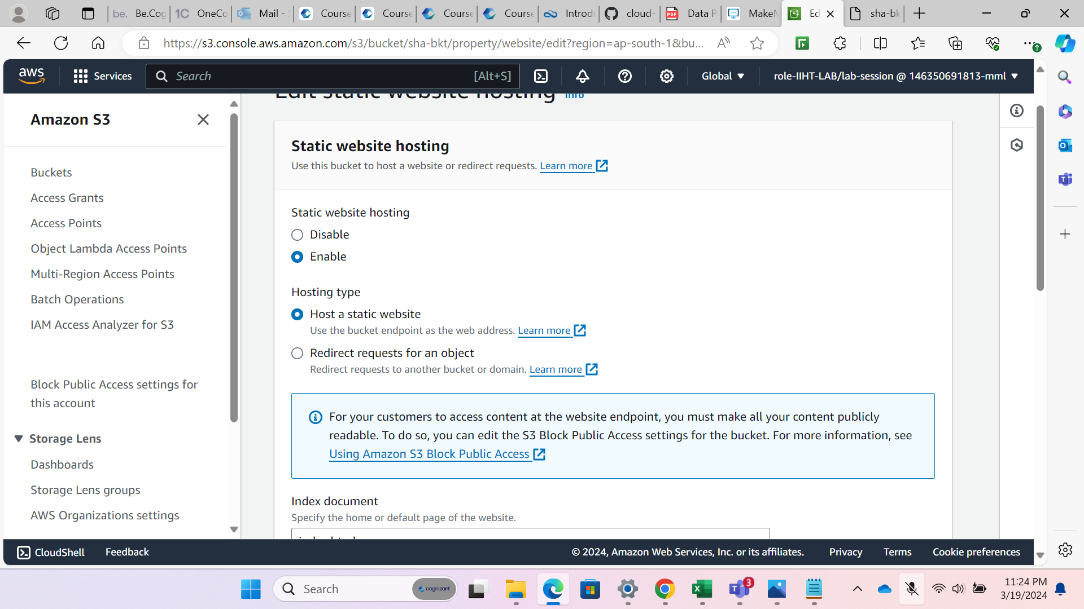

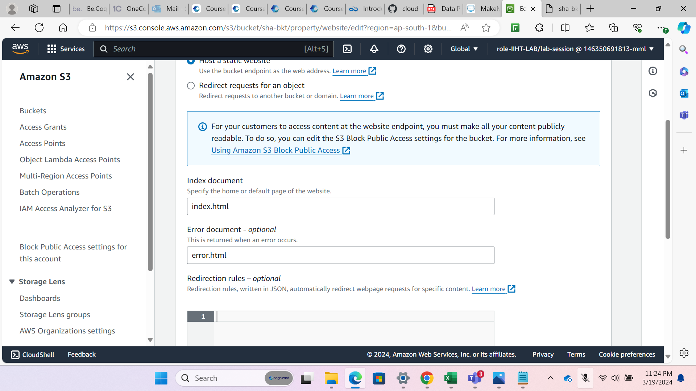

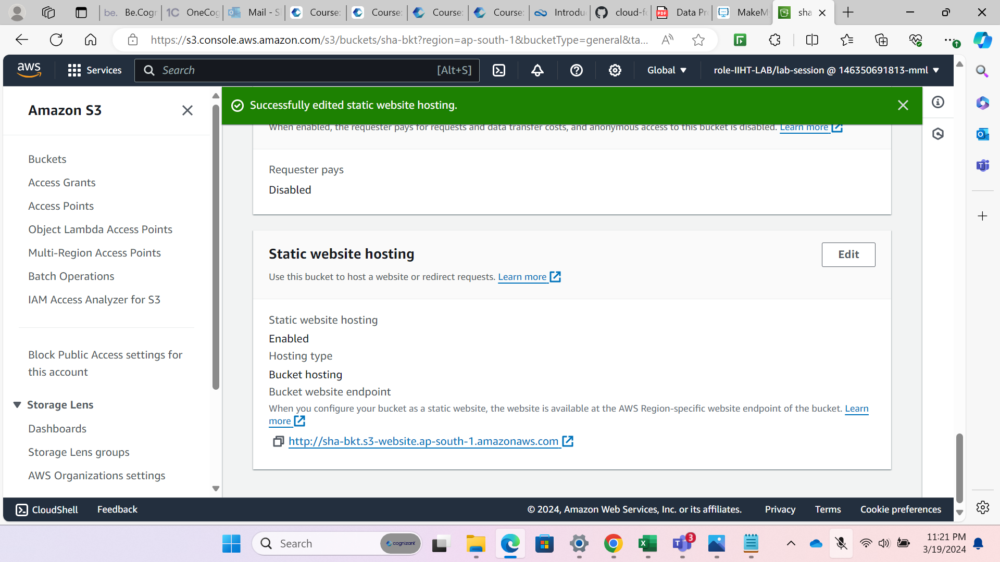

1. Paste the url on browser to access the website.

